Design Models

Christian Wagner and David Burmeier

Software Engineering of Real-time Systems

Due 11/29/16

The models and diagrams in this document represent the design process so far for our Audio File Player System.

1. System Structural Model
2. Requirements Model
3. Analysis Model
4. Design Model

**1. System Structural Model**

**Composition Hierarchy**



**Software System Context Diagram**



**Conceptual Structural Model**



**System Context Diagram**



**2. Requirements Model**

**Use Case Diagrams**

Use Case 1 (Indexing):



Use Case 2 (Playing):



**State Diagram**



**Use Case 1: Indexing**

Summary

User is indexing through audio files on the USB thumb drive with the name of the file displayed on the user interface.

Actors

Human user (primary actor), USB (secondary actor)

Preconditions

USB already in board, PC powered on, PC and board connected, music is either playing or not started

Main Sequence

1. User opens GUI and system displays first indexed audio file.
2. User scrolls through indexed audio files, and system displays selected index location.
3. User hits “play” on desired audio file, starting playback from beginning of song.

Alternate Sequences

1. If music is already playing, user pauses play of music (doesn’t change rest of main sequence).
2. If first indexed audio file is desired audio file, skip step 2 and go to step 3.
3. If selected file was just playing, play from saved position.

Postcondition

System is playing desired audio file.

**Use Case 2: Playing**

Summary

System is playing audio files until paused by user.

Actors

Human user (primary actor), USB (secondary actor)

Preconditions

USB already in board, PC powered on, PC and board connected, music is not playing

Main Sequence

1. User hits “play” on desired audio file.
2. User hits “pause”, system saves position of playback.

Postcondition

Playback is paused, system is in indexing state.

**3. Analysis Model**

**Indexing Use Case Sequence Diagram**

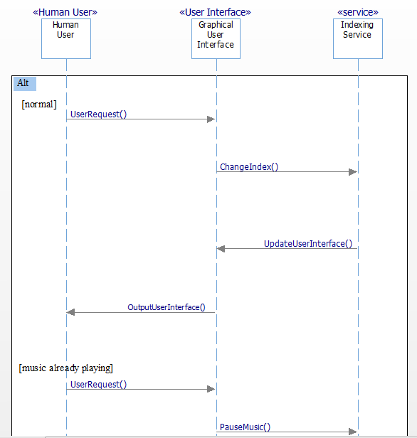

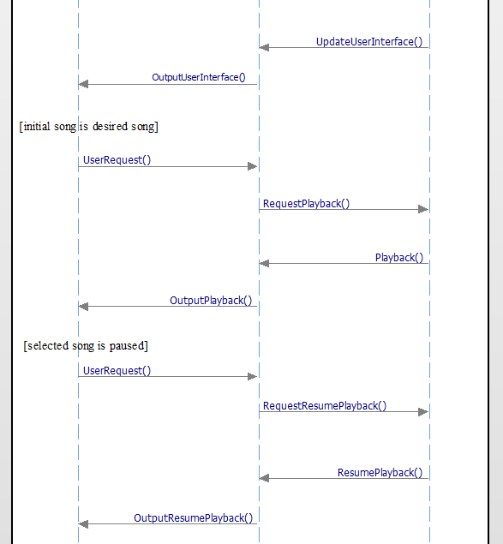

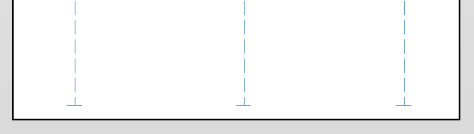

**Playing Use Case Sequence Diagram**



**4. Design Model**

**Integrated Communication Diagram**

